

FLY AWAY PLUS

Screen design

Hanoi, Jun/13/2015

Project Code: FAP

Document Code: FAP_ Screen Design_v1.0_EN

**SIGNATURE PAGE**

AUTHOR: Nguyễn Minh Hoàng 13/06/2015

Team member

REVIEWERS: Hoàng Nghĩa Đức 13/06/2015

Project Manager

APPROVAL: Nguyễn Văn Sang --/--/2015

Supervisor

**RECORD OF CHANGE**

*A - Added M - Modified D – Deleted

|  |  |  |  |  |  |
| --- | --- | --- | --- | --- | --- |
| Effective Date | Changed Item | A,M,D | Change Description | Reason for Change | Rev. Number |
| 13/Jun/2015 | Create Screen Design | A |  |  | 1.0 |
|  |  |  |  |  |  |
|  |  |  |  |  |  |
|  |  |  |  |  |  |
|  |  |  |  |  |  |
|  |  |  |  |  |  |
|  |  |  |  |  |  |
|  |  |  |  |  |  |
|  |  |  |  |  |  |
|  |  |  |  |  |  |
|  |  |  |  |  |  |
|  |  |  |  |  |  |
|  |  |  |  |  |  |
|  |  |  |  |  |  |
|  |  |  |  |  |  |
|  |  |  |  |  |  |
|  |  |  |  |  |  |
|  |  |  |  |  |  |
|  |  |  |  |  |  |
|  |  |  |  |  |  |
|  |  |  |  |  |  |
|  |  |  |  |  |  |
|  |  |  |  |  |  |
|  |  |  |  |  |  |
|  |  |  |  |  |  |
|  |  |  |  |  |  |

# **INTRODUCTION**

## Purpose

To ensure consistency and simplicity in detailed design across all displays within a product interface, as well as across other products used by the same users. Definitions, acronyms, abbreviations, references and overview of FAP website.

## Definitions, Acronyms and Abbreviations

|  |  |  |
| --- | --- | --- |
| Abbreviations | Description | Comment |
| FAP | Fly Away Plus | Social network of travelling |
| Q&A | Question and answer |  |

## Overview

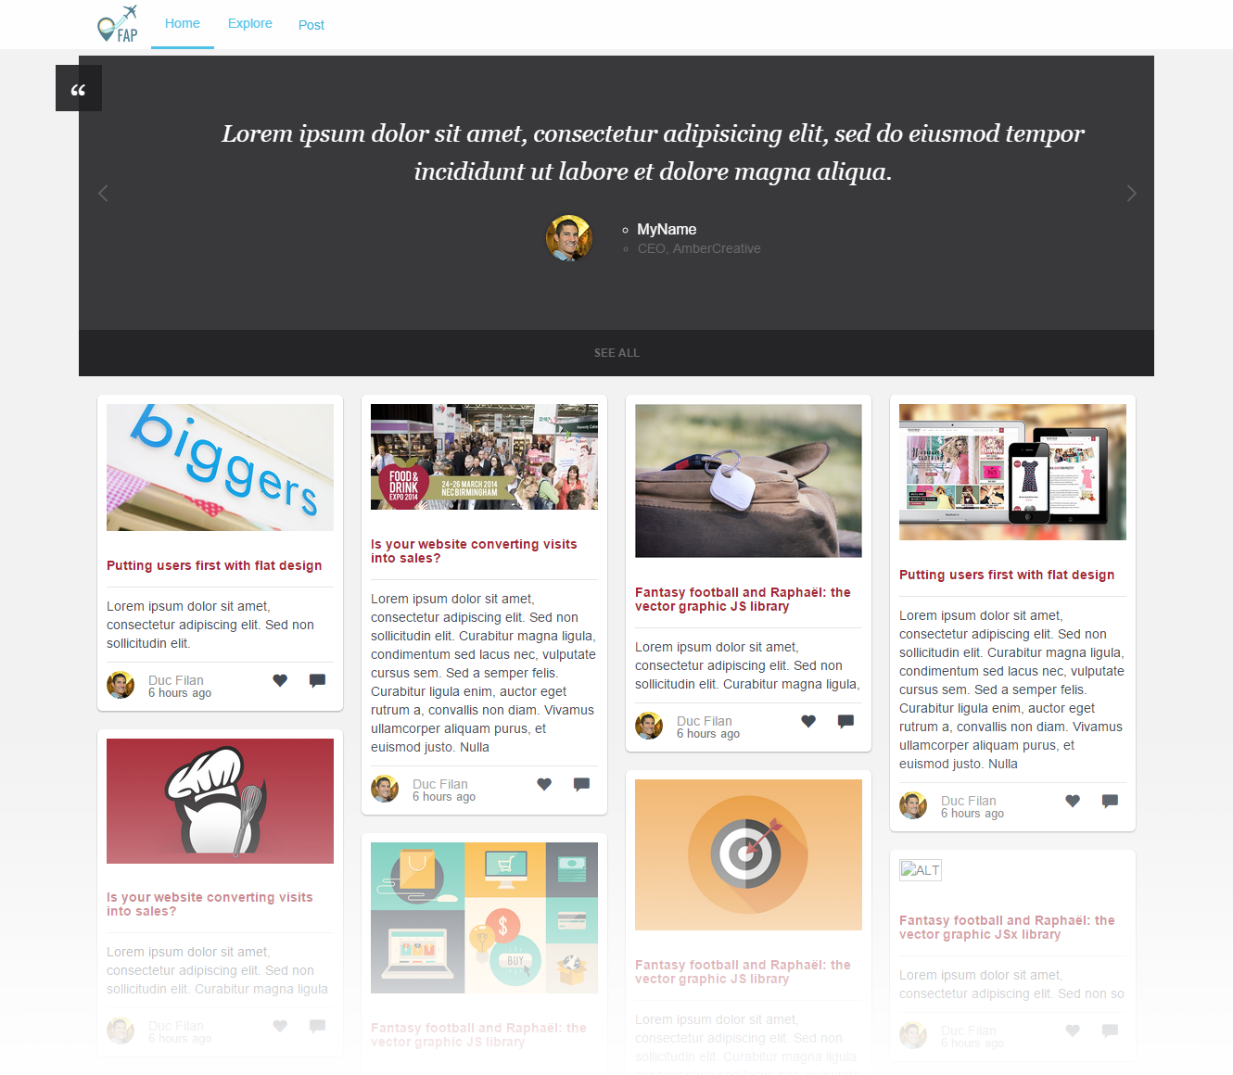

# **SCREEN FLOW**

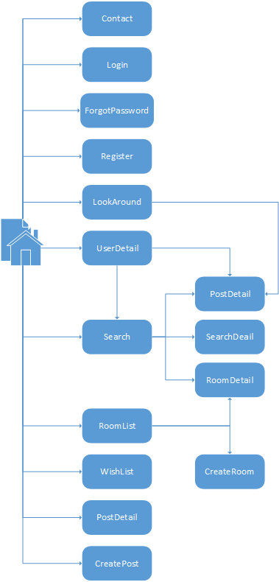

|  |  |  |
| --- | --- | --- |
| No | Screen Name | Description |
| 1 | Homepage | Homepage |
| 2 | Contact | Contact admin |
| 3 | Login | Login as a member |
| 4 | Register | Create New Account |
| 5 | Forgot Password | Get a new password in case of forgetting password |
| 6 | Look Around | Look around current position to find travelling places |
| 7 | User Detail | Timeline and information of user |
| 8 | Search | Search result |
| 9 | Room List | List of rooms |
| 10 | Search Detail | Detail information of a place |
| 11 | Room Detail | Detail information of a room |
| 12 | Post Detail | Detail information of a post |
| 13 | Wish List | List of places to visit in the future |
| 14 | Create Post | Create a post for a place |
| 15 | Create Room | Create a new room |

## Look around

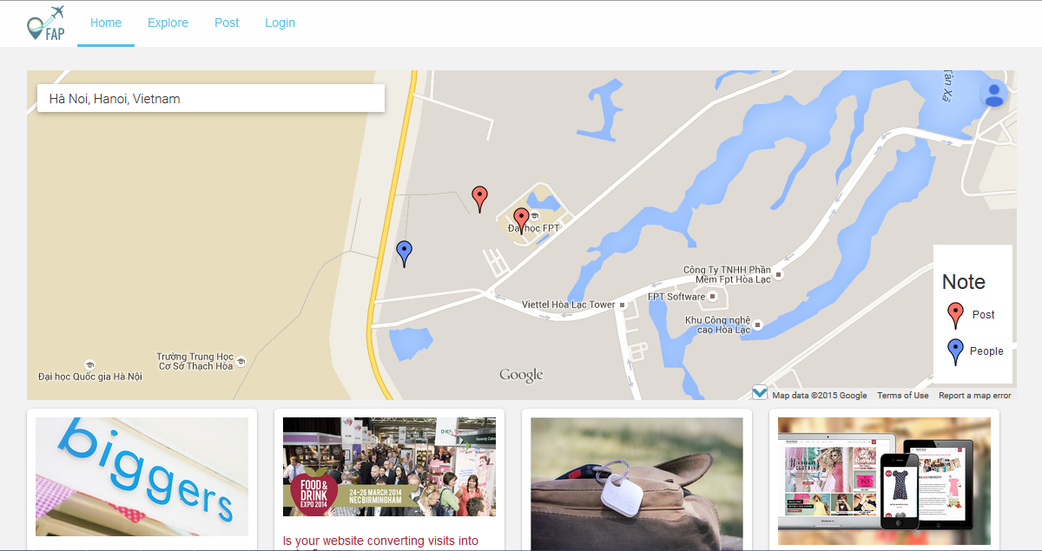

### Figure 1: Look around

|  |  |  |  |  |  |  |  |
| --- | --- | --- | --- | --- | --- | --- | --- |
| No | Field name | Field name in Vietnamese | Type | Require | Mand-atory | Max-Length | Description |
| 1 | Logo | Logo | Image | Image |  |  | Logo of FAP website |
| 2 | Home | Trang chủ | Button | Click | Y |  | Redirect to home page |
| 3 | Post | Đăng bài | Button | Click | Y |  | User want to post a new post |
| 4 | Top Posts | Bài đăng tiêu biểu | Slide |  |  |  | Slide of top posts |
| 5 | Post List | Danh sách bài đăng | List |  |  |  | Show list of post |
| 6 | Search box | Ô tìm kiếm | Text box | Click | Y |  | User type location where they want to search about it |
| 7 | Map | Bản đồ | Google map | N/A | Y |  | Display user’s location and location which they searched |
| 8 | Lengend | Bảng chú thích bản đồ | HTML | N/A | Y |  | Explain icons that display on map |
| 9 | Minimize & maximize map | Thu nhỏ & phóng to bản đồ | Button | Click | Y |  | Minimize & maximize map |